**Level 1**

**Bug #1**

**Summary:** Mixed positions of goods and services while opened barber services page

**Priority:** P2

**Severity:** S3

**Steps:**

1. Open site <https://www.atlantas24hourbarbershop.com/>
2. Drag down to website catalog
3. Pay attention to catalog services

**Expected result:** Only barber shop services listed

**Actual result:** Mixed positions of goods and services are available

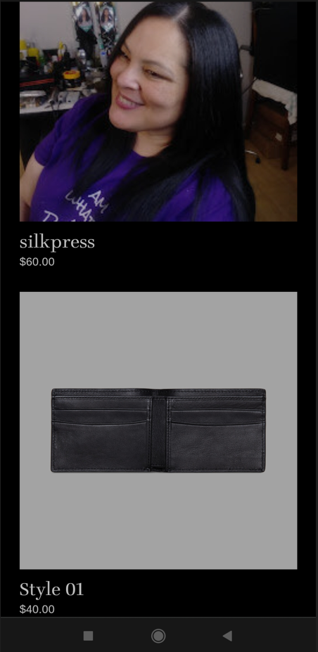

**Environment:** Android 11 (R), Xiaomi Redmi Note 9, Google Chrome

**Bug #2**

**Summary:** Missing complete list of selling goods at merchandise section of the website

**Priority:** P1

**Severity:** S1

**Steps:**

1. Open site <https://www.atlantas24hourbarbershop.com/atlantas-barber-supply-and-accessories>
2. Pay attention that only single item is available in the list

**Expected result:** Complete list of selling list is available

**Actual result:** Missing complete list of selling goods

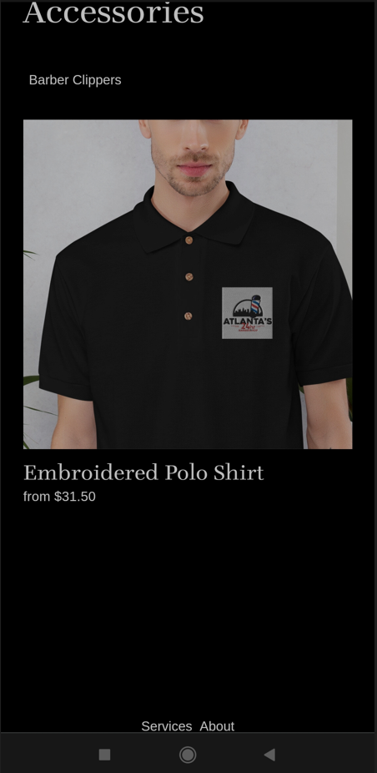

**Environment:** Android 11 (R), Xiaomi Redmi Note 9, Google Chrome

**Bug #3**

**Summary:** Possibility to add hairstyle into the shopping cart while opened barber services page

**Priority:** P1

**Severity:** S2

**Steps:**

1. Open site <https://www.atlantas24hourbarbershop.com/>
2. Drag down to website catalog
3. Click on any hairstyle service mentioned in the catalog
4. Click “Purchase” button
5. Pay attention that hairstyle chosen is added into the cart

**Expected result:** Hairstyle is not possible to add into the shopping cart

**Actual result:** Possibility to add hairstyle into the shopping cart

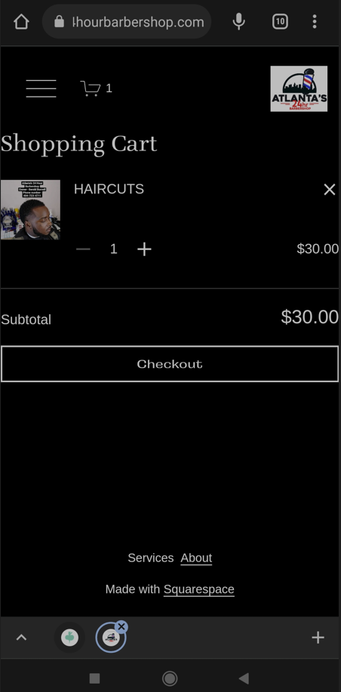

**Environment:** Android 11 (R), Xiaomi Redmi Note 9, Google Chrome

**Bug #4**

**Summary:** Missing rating functionality at website while it’s mentioned in site description

**Priority:** P2

**Severity:** S2

**Steps:**

1. Open site <https://www.atlantas24hourbarbershop.com/>
2. Drag down to the end of website description
3. Pay attention to the mentioned shop rating.
4. Click on any hairstyle service or goods mentioned in the catalog
5. Pay attention that rating functionality is not supported

**Expected result:** Rating functionality is available under service or goods

**Actual result:** Missing rating functionality at website

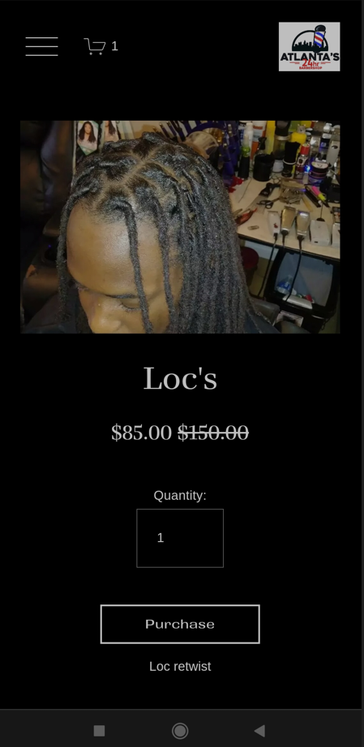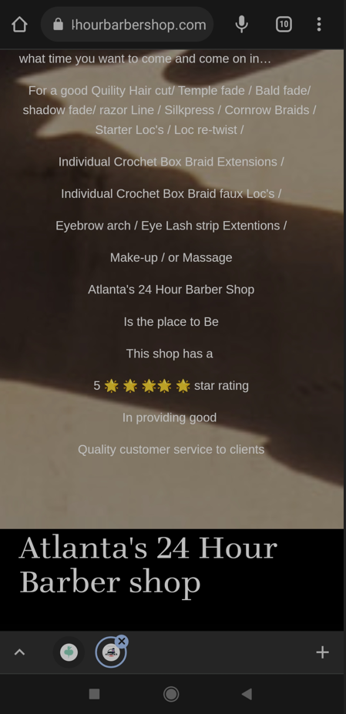

**Environment:** Android 11 (R), Xiaomi Redmi Note 9, Google Chrome

**Bug #5**

**Summary:** Mixed text alignment and indentation at the website description form

**Priority:** P2

**Severity:** S3

**Steps:**

1. Open site <https://www.atlantas24hourbarbershop.com/>
2. Drag down to the website description
3. Pay attention and compare at text alignment and indentation

**Expected result:** Text alignment and indentation has the single structure

**Actual result:** Mixed text alignment and indentation at the website description form

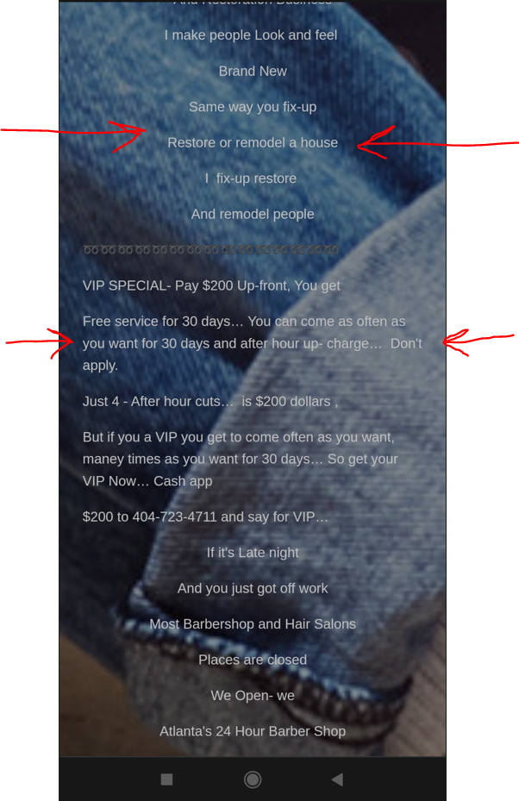

**Environment:** Android 11 (R), Xiaomi Redmi Note 9, Google Chrome

**Level 2**

**Bug #1**

**Summary:** Mixed text styles in the names of services at the barber website catalog

**Priority:** P3

**Severity:** S4

**Steps:**

1. Open site <https://www.atlantas24hourbarbershop.com/>
2. Drag down to the website catalog
3. Pay attention and compare at text styles in the services names

**Expected result:** Text styles are the same for each services names

**Actual result:** Mixed text styles in the names of services

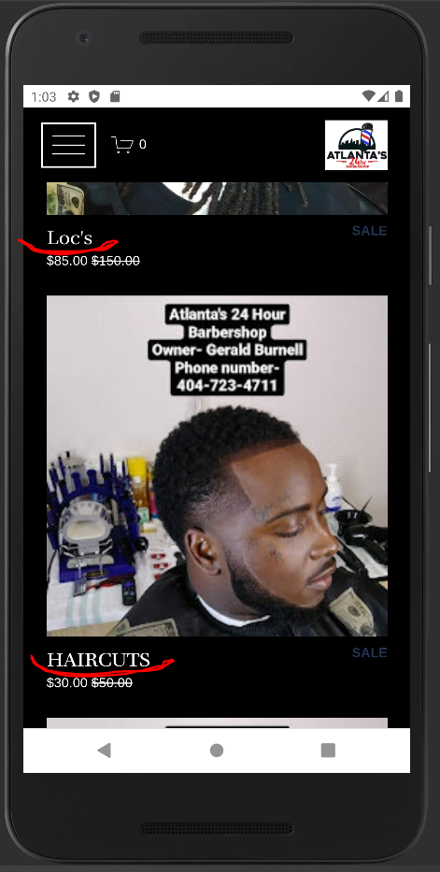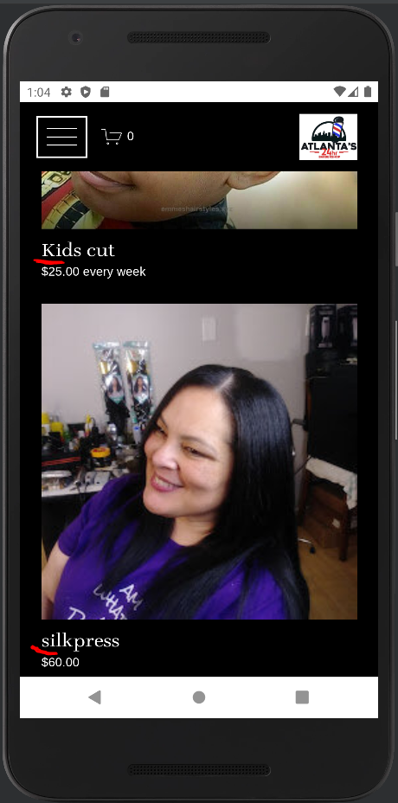

**Environment:** Android 11 (R), Nexus 5X (emulator), Google Chrome

**Bug #2**

**Summary:** Photos of goods are cutted at the pictures carousel of goods in choose menu

**Priority:** P1

**Severity:** S2

**Steps:**

1. Open the goods <https://www.atlantas24hourbarbershop.com/store-1/p/dad-hat>
2. Pay attention on goods picture at the pictures carousel

**Expected result:** Full size picture is shown at the pictures carousel

**Actual result:** Photos of goods are cutted at the pictures carousel

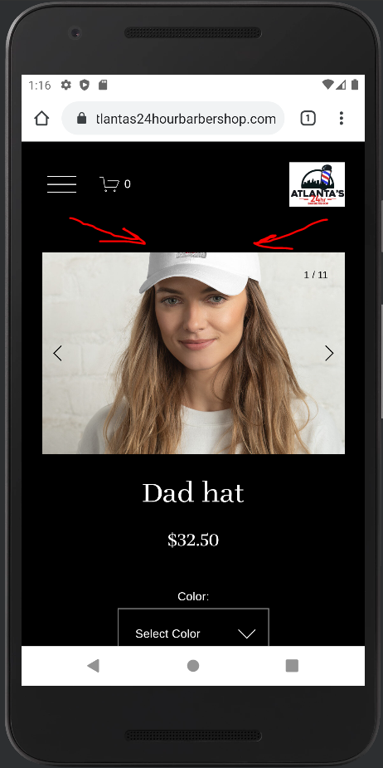

**Environment:** Android 11 (R), Nexus 5X (emulator), Google Chrome

**Bug #3**

**Summary:** Similarhairstyle names of categories shown in the categories header

**Priority:** P2

**Severity:** S2

**Steps:**

1. Open the goods <https://www.atlantas24hourbarbershop.com/>
2. Pay attention on categories name list

**Expected result:** Single name represents single category

**Actual result:** Similarhairstyle names of categories shown in the categories header

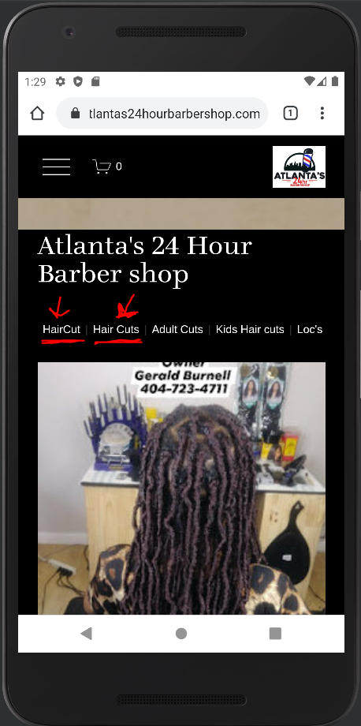

**Environment:** Android 11 (R), Nexus 5X (emulator), Google Chrome

**Level 3**

[Check list](https://docs.google.com/spreadsheets/d/1G_Y2uXW7tVrn5dKd_WgfU6WUAN8W71hlmo4Payi2kn4/edit?usp=sharing)